Application Of Artificial Intelligence(AI) in Agriculture
Abstract:
The rapid growth of the global population combined with the intensifying effects of climate change presents unprecedented challenges in agriculture, necessitating the adoption of innovative technologies to sustain and increase food production. Artificial intelligence (AI) stands out as a pivotal technology transforming agriculture by enabling robotic automation, advanced machine learning, and precision farming techniques. AI integration enhances decision-making in crop management, offering real-time monitoring, predictive analytics, and optimized resource allocation. Genetic improvements paired with AI-driven resource use contribute to higher yields and greater resilience in farming systems. Specific AI methods like Convolutional Neural Networks (CNNs) enable early disease detection through image-based crop classification, significantly reducing yield losses. Long Short-Term Memory (LSTM) networks facilitate predictive modeling for yield forecasting and soil health assessments, thereby improving resource allocation. Collectively, these technologies form the foundation of modern, data-driven agriculture capable of responding effectively to current and future challenges.
1.Introduction
Agriculture plays a fundamental role in ensuring food security at both national and global levels. As one of the oldest human practices, it remains indispensable for survival, providing essential resources such as food, oil, clothing, and other basic necessities (1). Without agriculture, sustaining human life would be nearly impossible (1). Beyond meeting basic needs, agriculture also forms the backbone of economic sustainability in many countries (2).
In populous nations such as India, agriculture continues to be a key contributor to the economy, accounting for approximately 18.3% of the country’s Gross Domestic Product (GDP) in 2023. In comparison, China’s agricultural sector contributed about 6.89% to its GDP in the same year (3,4) . The need for sustainable improvement in production methods remains urgent to meet the demands of a growing global population and to safeguard food security in the future (5). The global population is projected to reach approximately 9.9 billion by 2050, creating a significant challenge for food security. Correspondingly, food demand is expected to rise by 35% to 56% within this period (6). To meet this demand, crop production will need to nearly double compared to 2005 levels by 2050 (7). Achieving this target requires coordinated global efforts, including the adoption of advanced agricultural practices, shifts in dietary patterns, reductions in food loss and waste, and more efficient use of available farmland (8). Furthermore, maximizing yields is becoming increasingly difficult due to compounding challenges, notably climate change, the spread of pests and weeds, and the prevalence of crop diseases (9). The integration of advanced technologies such as the industrial Internet, cloud computing, and AI-driven tools has significantly influenced both societal development and the global economy (10).
2.Using AI to Modernize Agriculture:
Agriculture has entered a transformative new era of digitalization. The rapid advancement of the digital economy—driven by cutting-edge technologies such as the Industrial Internet, cloud computing, and AI-powered tools like ChatGPT—has profoundly impacted people's daily lives and reshaped the global economy (10). To adapt to these evolving demands, the agricultural sector must pursue a deeper and broader information reform, leveraging digital tools to enhance productivity, sustainability, and efficiency across the entire value chain (11).
2.1 The concept of AI: In 1956, John McCarthy first introduced the term “Artificial Intelligence” at a conference held at Dartmouth College. He imagined creating machines that could imitate human intelligence (12). Artificial Intelligence (AI) is a field of computer science that uses techniques like Machine Learning (ML) and Deep Learning (DL) to learn from data and copy how humans think and solve problems. These algorithms study the relationship between input and output data to make predictions, which help solve both simple and complex issues (13). AI is based on the idea that human intelligence can be described clearly so that computers can copy it and perform tasks of any size (14).The core aim of AI machines is to learn from data, make decisions, and understand their surroundings (15).
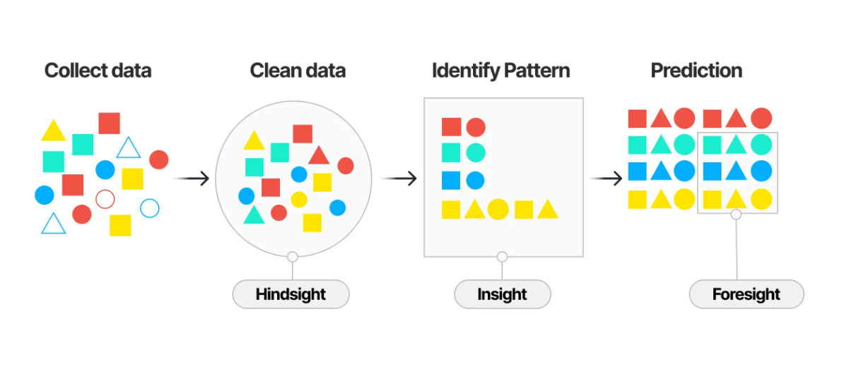
Figure: 1, Overall working diagram of AI based system (16).
Another subset is Artificial Neural Networks (ANN), inspired by the human brain’s structure and processes, which have strong abilities to organize themselves and learn adaptively (17).
2.2. Key technologies for AI Empowered agriculture: The main principle behind AI-powered agriculture is based on three key technologies: information perception, transmission, and processing. Information perception involves gathering important data about farming activities, such as planting and crop growth (18).
A wide array of technologies is shaping the evolution of smart agriculture, including machine learning, deep learning, wireless sensor networks (WSN), Internet of Things (IoT), robotics, cloud computing, and big data analytics (19).In contrast, deep learning architectures employ multi-layer feature extraction techniques to transform raw datasets into actionable insights, significantly improving decision-making for crop management and yield prediction (20).
Together, these technologies establish the framework for agricultural decision-making systems that are both data-driven and future-oriented (21).

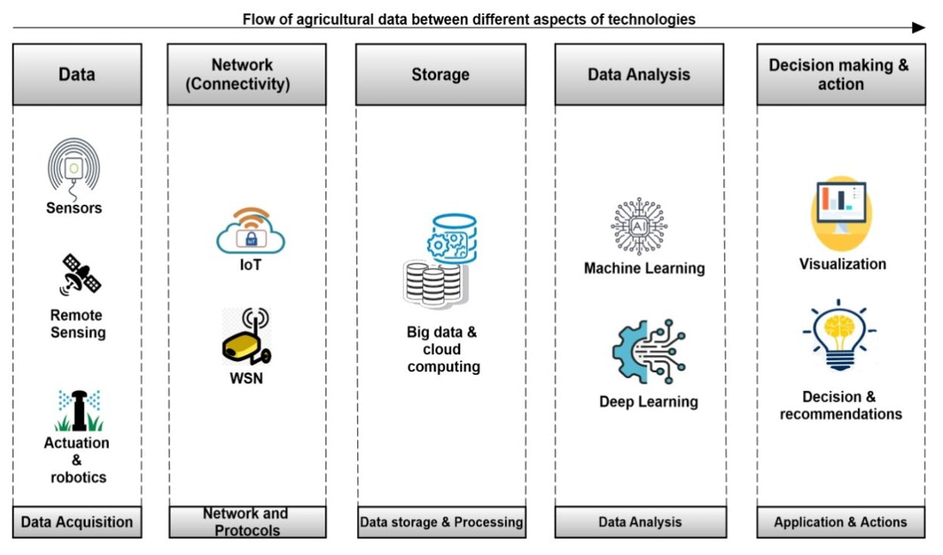
Figure 2: Core technologies behind AI integrated agriculture (21).
2.2.1 Sensors and Robotics
Sensors represent the foundation of smart farming systems, providing real-time environmental awareness at low cost and high efficiency. Advanced sensors—both wired and wireless—have been integrated into various agricultural systems over the past decades (22).Applications of agricultural sensors include soil moisture monitoring, irrigation optimization, weed management, and crop disease detection (23). With AI integration, remote sensing supports the monitoring of crop nutrient levels, water status, soil quality, and disease spread (24).
Mobile robots—supported by UAVs and unmanned ground vehicles (UGVs)—offer significant advantages by covering larger areas and operating across varied terrains. These robotic systems enhance productivity, reduce dependency on manual labour, and support precision farming practices (25). Through IoT frameworks, farmers can monitor livestock, weather, crop conditions, and supply chains in real-time. Typically, IoT architecture comprises three layers: a perception or sensor layer, a network layer for communication, and a top layer encompassing applications and user functionalities (26). These sensor-based networks monitor air quality, humidity, soil moisture, and temperature with high efficiency (27). Collectively, IoT and WSN technologies improve decision-making, minimize human intervention, and drive efficiency and sustainability in agriculture (28).
2.2.3 Cloud Computing and Big Data
Cloud computing provides the infrastructure for effective data storage, management, and analysis in smart agriculture. It offers cost-efficient, web-based storage services for farm management, allowing seamless processing of agricultural data (29).
Despite its potential, cloud computing faces challenges when handling vast agricultural datasets, especially in low-latency environments (30). To address this, fog and edge computing solutions have been introduced, enabling real-time analytics at the network’s edge (31).
Big data analytics, in particular, serves as a transformative force in agriculture. Using the 5Vs model—volume, velocity, variety, veracity, and value—big data techniques enable farmers to analyse vast datasets on temperature, rainfall, soil, and seed performance (32).
2.2.4 Machine Learning and Deep Learning
The exponential rise in agricultural data, driven by IoT, WSN, and cloud computing, provides fertile ground for AI algorithms (33).
Algorithms such as Random Forest (RF), Support Vector Machines (SVMs), and advanced DNNs are already being applied to deliver actionable recommendations in near real time (34).
2.2.5 Decision-Making Systems
Decision-making systems (DSS) integrate raw data and analytical tools to generate actionable knowledge, presented via user-friendly interfaces. By converting datasets into meaningful decision support, DSS technologies provide valuable guidance for farmers and stakeholders facing complex or poorly defined challenges (35).
Several agricultural DSS frameworks have been developed in recent decades. For instance, the AgriSupport-II system provides farm planning algorithms based on factors such as technical paths, resource allocation, and cost optimization (36).
2.2.6 Computer vision:
Computer vision is a type of technology that lets machines understand and analyse images or videos to identify objects and patterns. It focuses on helping computers gain a higher-level understanding of visual data, so they're able to make decisions based on what the camera or sensor 'sees' (37).
A key technology in computer vision is the convolutional neural network (CNN), which is designed to process images efficiently and identify features—making CNNs very useful for agricultural applications like monitoring crops and sorting produce. In agriculture, computer vision is being used for tasks such as planting, harvesting, weed and pest detection, and crop health monitoring (38).Computer vision tools in agriculture are helping farms of all sizes—ranging from space-focused enterprises using satellites, to small startups on the ground—bring about a major shift in how agricultural business is conducted (39).
Table,1: Comparison of AI- driven and Traditional agricultural techniques.
Traditional agricultural methods | AI- powered smart agricultural method | Advantages of using Smart irrigation system | Disadvantages | References
Manual- labour based decision making | Precision farming, autonomous machinery, predictive analysis and drone technology. | Improved efficiency, Improved yield prediction and reduced cost of labour workers crop monitoring and disease prevention. | Higher cost, requirement of technical expertise and infrastructure. | 40
Manual crop monitoring and the traditional method of irrigation. | All terrain vehicles (ATV) are based on automation of tasks including planting, weeding, harvesting, etc.. | 15% to 20% increase in yield, 25%-30% reduction in overall investment. | Requires training, low accessibility in remote sensing areas. | 41
Old water based irrigation system and weeding practices. | Robotic systems for weeding and irrigation. | Saving water, preserving soil fertility, limiting use of herbicides, pesticides and effective use of labour. | High initial cost and the requirement of infrastructure. | 42
Manual mapping and survey method | Use of ML, DL, and ANN for agricultural mapping. | Enhanced land use mapping , crop identification and disease control. | Requirement of technical expertise. | 43

3. Application of AI in Agriculture:
The application of AI in agriculture has attracted researchers’ attention since the early days of artificial intelligence. The first known use dates back to the 1960s, when scientists began exploring computer vision and image processing to analyse crop photographs (39).
During this period, AI-powered systems for precision farming emerged, using data from sensors and cameras to provide farmers with real-time insights into crop conditions. In recent years, with advancements in technology and greater availability of agricultural data, AI applications have expanded significantly (44).
There are several applications of AI in agriculture, that are following:
3.1 Precision farming applications of AI in agriculture:
Precision farming is one of the most practical applications of AI in agriculture. Precision farming aims to improve the use of fertilizer and other resources at the right time. Some examples of AI-powered precision farming applications include (45):
3.1.1Crop scouting:
AI-powered systems can analyse crop images to identify issues such as pests, diseases, or nutrient deficienciesTools like Taranis and Plantix help farmers detect problems early and take action to prevent crop loss.
3.1.2 Variable rate application:
Variable Rate Irrigation (VRI) is an advanced system that applies precise amounts of water through the integration of sensors, GPS, and data analytics (46). Recent research also reported an irrigation efficiency of 87.97% when cultivating Geranium psilostemon with modern smart irrigation methods, showing clear advantages over traditional practices in optimizing water use (47).
Researchers explored using computer vision to analyse soil texture and organic matter by training an algorithm with images from an affordable handheld microscope.This approach offers a faster, less labour-intensive alternative to traditional soil analysis methods (45).
3.1.3 Autonomous tractor:
Smart tractors now include several advanced features:
- GPS Navigation: Helps tractors move and work with accuracy, leading to better plowing, planting, and harvesting while reducing waste.
- Data Analytics: Sensors on the tractor collect details about soil, crops, and weather. AI studies this data and gives farmers useful advice for better farm decisions.
- Autonomous Work: Some tractors can work without a driver, saving time and lowering labour costs.
- Remote Monitoring: Farmers can use mobile apps to check their tractors and fields, making it easier to
3.2 Yield prediction applications of AI in agriculture:
Machine learning (ML) has become an important tool for building prediction models. It functions by training a model using historical data, evaluating its performance with new inputs to test accuracy, and then applying it to generate reliable future predictions (48).

Table,2: AI Powered Deep Learning models for crop yield predictions.
Crop | AI-Technique | Data source | Advantage | Reference
Soyabean | CNN-LSTM | Satellite data | It can provide satisfactory result for early prediction with high accuracy. | 50
Corn | CNN | Hyperspectral imagery | 75.50% crop classification accuracy | 51
Wheat, Corn | Spatial Spectral Temporal Neural Network (SSTNN) | Spatial spectral temporal data | Provides high yield predictions with accuracy. | 52
Cereal( Wheat, corn, and Barley) | UAV based remote sensing, 3-D-CNN | High resolution Unmanned aerial vehicle(UAV) image data | At intra-field scale it can gives more accurate yield prediction. | 53

3.3 Crop monitoring applications of AI in agriculture:
Artificial Intelligence plays a key role in crop monitoring by analysing large volumes of data from drones, sensors, cameras, and weather stations, and making accurate predictions about crop health and growth (48).
Some applications of AI in agriculture include:
3.3.1 Crop disease detection:
To optimize agricultural yield, effective disease management is essential, as plant and animal diseases significantly limit production. Various environmental and genetic factors, including soil type, rainfall, temperature, wind, and genetic susceptibility, influence disease development. To effectively control diseases and minimize losses, farmers should adopt an integrated disease control and management model that combines physical, chemical, and biological measures (54).
3.3.2 Crop growth monitoring:
Using satellite imagery has been shown to double the effectiveness of agricultural interventions, resulting in improved crop yield and efficiency. This approach is considered sustainable for enhancing food production. (56).
This model has proven more accurate than human observation, allowing farmers to monitor their crops without daily field visits. Similarly, another study used an algorithm to analyse tomato colour development for maturity detection, achieving a classification accuracy of 99.31% (57).
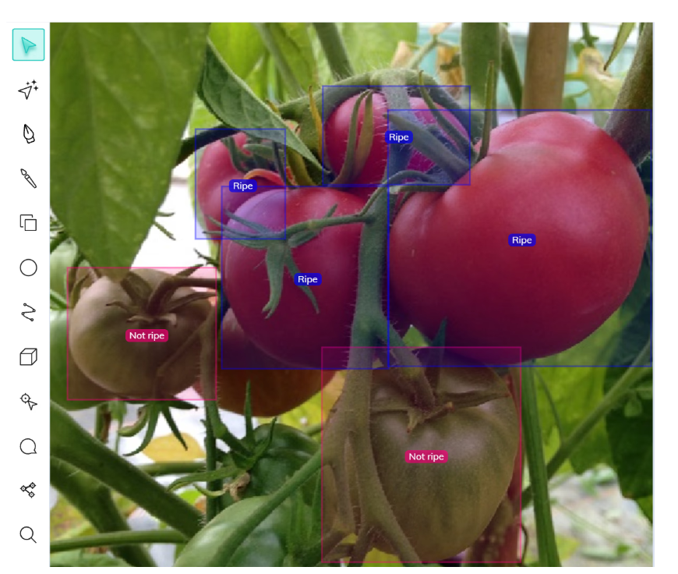
Figure 3: Tomato maturity detection using computer vision involves analyzing color from multiple parts of the tomato with an algorithm to accurately estimate ripeness (44)
Platforms like Taranis and Prospera use high-resolution imagery and AI models to deliver actionable insights to farmers (57).
3.3.3 Crop water management:
AI models utilize data from weather stations, soil moisture sensors, and satellite imagery to optimize irrigation schedules by accurately predicting when and how much water crops need. Tools like CropX and Arable harness these technologies to reduce water consumption while boosting crop yields, ensuring that crops receive the right amount of water at the ideal times. This smart water management not only conserves valuable water resources but also improves overall farm productivity and sustainability (58).

3.3.4 Crop inventory management:
AI systems use advanced computer vision combined with drone imagery to create detailed maps of crop distribution and assess overall crop health. Platforms such as Agremo and SkySquirrel analyse these images along with other data to estimate yield potential and provide valuable insights that help farmers manage their crops more effectively. This technology improves crop inventory management by offering precise, real-time information that supports better decision-making, reduces waste, and enhances productivity (59).
Table 3: AI techniques and its strength and limitations for crop management.
Technique | Strength | Limitation | Reference
CALEX | Can formulate scheduling guidelines for crop management activities. | Takes time. | 60
PROLOG | Removes less used farm tools from the farm. | Location specific. | 61
ANN | Predict crop yield. | Only captures weather as a factor for crop yield. | 62
ROBOTICS | Has 80% success rate in harvesting crops. | Slow picking speed and accuracy. | 63
FUZZY Cognitive map | Predict cotton yield and improve crop for decision management. | Relatively slow. | 64
ANN and FUZZY Logic | Reduces insects that attack crops. | Shows inability to differentiate between crop and weed. | 65
ANN | Can accurately predict rice yield. | Time consuming , limited to a particular climate. | 66

3.4 Weather forecasting applications of AI in agriculture:
AI approaches are increasingly used in weather forecasting applications for agriculture to analyse data from multiple sources, such as weather stations, satellites, drones, and IoT sensors.
Examples of AI tools and their work patterns:
IBM Weather Company: Uses AI and machine learning to process data from satellites, IoT devices, and radar (67).
Microsoft AI for Earth (FarmBeats): Integrates AI with weather station, drone, and soil data to deliver farm-specific weather predictions. Its models can identify temperature and rainfall patterns, enabling farmers to schedule planting and predict disease risks tied to humidity and precipitation (68).
ClimaCell (Tomorrow.io): Uses AI to combine sensor data, satellite imagery, and atmospheric models for real-time micro-weather forecasts. It provides actionable in-field alerts, such as predicting frost events, drought spells, or heavy rainfall, so farmers can act before damage occurs (69).
Auravant: Leverages AI to merge weather data, crop models, and satellite observations. It helps farmers with long-term forecasts and simulation of scenarios, such as estimating the effect of drought conditions on crop yield (70).
The Climate Corporation (Climate FieldView)
Uses AI-powered predictive models to integrate historical weather data with live climate observations. It supports farmers with decisions around planting dates, irrigation management, and pest/disease prevention strategies based on predicted weather conditions (71).
3.5 Predictive maintenance applications of AI in agriculture:
Agricultural machinery—tractors, harvesters, irrigation systems—faces significant wear due to continual operation and challenging environments. To mitigate these challenges farmers have traditionally depended on two main maintenance approaches for their equipment: reactive and preventive maintenance. Reactive maintenance is performed only after a breakdown has occurred, often resulting in extended downtime, lost productivity, and costly emergency repairs. Preventive maintenance, by contrast, involves scheduling regular inspections and repairs based on fixed intervals, without regard to the actual condition of the machinery. While this reduces the chance of sudden failures, it can lead to unnecessary servicing and increased costs since equipment may be maintained even if it is still in good working order (72).
Predictive maintenance uses real-time data from IoT sensors embedded in farm machinery, combined with AI analytics, to continuously monitor equipment health. By analysing indicators such as temperature, vibration, oil levels, and engine performance—alongside historical data and environmental factors—predictive systems can forecast exactly when maintenance should be performed. This approach allows farmers to focus maintenance efforts only when necessary, preventing unforeseen breakdowns, reducing downtime during critical farming periods, and optimizing the deployment of resources (72).
In addition, predictive maintenance contributes to farm safety. By identifying and addressing mechanical problems before they cause equipment malfunctions, it reduces the risk of accidents and injuries. Beyond preventing failures, it provides farmers with valuable, data-driven insights, helping them schedule maintenance at the most convenient times and optimize overall equipment management (44).
One study shows a large-scale farm in the United States implemented a predictive maintenance system for its irrigation infrastructure by deploying IoT sensors to continuously monitor critical parameters such as water pressure and flow rates. This early detection mechanism enabled the farm to identify issues like leaks and blockages promptly, preventing excessive water loss and curbing potential system damage. Consequently, the farm reported a notable 15% reduction in overall water consumption along with a 20% decrease in maintenance costs, demonstrating both operational efficiency and sustainable resource management (73).
Examples of AI software for predictive maintenance in agriculture:
PROLOG uses weather data, machinery capacity, labour availability, and information on authorized and prioritized operators, tractors, and implements to assess farm system operations. It also forecasts crop production, gross revenue, and net profit for individual fields and the entire farm. This comprehensive evaluation supports optimized farm management and decision-making (50).
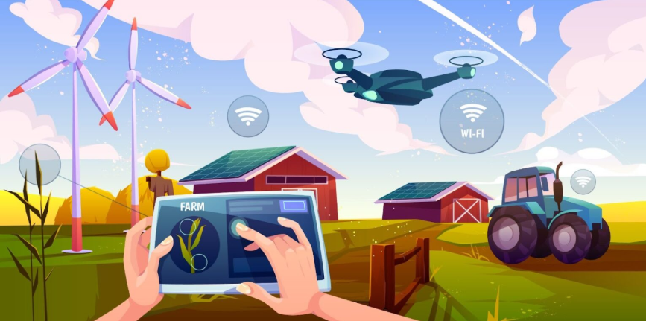
Figure,4: Animated illustration describing about predictive management of agriculture(72)
IBM Maximo Application Suite – Offers predictive maintenance solutions integrating IoT sensors and AI for tractors, irrigation pumps, and other machinery (73).
Uptake Agility – Uses AI models to monitor agricultural equipment performance and predict potential failures (73).
CognitOps for Agriculture – Provides AI-driven predictive analytics for farm machinery efficiency and reliability (74).
John Deere Operations Center – where IoT and AI technologies continuously monitor the health of agricultural assets. Farmers receive early alerts, actionable recommendations, and customized maintenance schedules, leading to a measurable reduction in downtime and operational costs (72).
3.6 Smart greenhouses applications of AI in agriculture:
Smart greenhouses are advanced greenhouses that use AI technologies to optimize plant growth and maximize crop yields. Sensors are installed to monitor key variables such as temperature, humidity, light intensity, carbon dioxide levels, and soil moisture—factors that directly influence plant health and productivity.

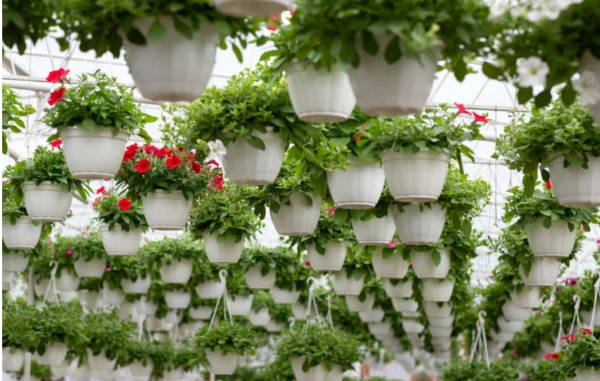
Figure 6: Glasshouse farming for increased yields and reduced pesticide use (44).
Examples of AI-powered smart greenhouse applications
Autogrow (New Zealand): Uses AI-driven climate control systems to automate irrigation, nutrient dosing, ventilation, and lighting. It applies predictive analytics to adjust growing conditions for different crops and maximizes yield outcomes (75).
iGrow (Indonesia): A greenhouse management platform that uses IoT sensors and AI to monitor temperature, humidity, and soil health. It connects farmers with remote monitoring and automated recommendations for plant care, reducing resource waste (76).
Plant Empowerment - LetsGrow.com (Netherlands): Provides AI-based cultivation insights by integrating sensor data from greenhouses. It focuses on plant physiology, delivering recommendations to balance energy use, water management, and crop productivity (77).
GreenIQ Smart Garden Hub (Israel): Uses weather forecasting data and soil sensors combined with AI predictions to optimize irrigation and fertilization schedules. This reduces water consumption while ensuring healthy plant development (78).
Microsoft FarmBeats for Greenhouses: Combines IoT sensors, drones, and AI algorithms to monitor greenhouse crops in real time. Its machine learning models optimize soil health, track temperature patterns, and generate data-informed insights for farmers (68).
3.7 Weed, pest, disease monitoring application of AI in agriculture:
Weeds and pests consistently reduce farmers’ expected profit and yield. For example, a report shows that weed infestations can reduce yields by up to 50% in dried beans and corn crops when not controlled (79). Wheat yield losses due to weed competition are about 48%, with losses sometimes reaching as high as 60% (80). A specific study on soybean reported yield reductions ranging from 8% to 55% due to weed competition (81). A study on yield losses in sesame crops estimates reductions of about 50%-75% due to weed competition (82). The variability in these yield losses may be explained by factors such as the length of crop exposure to weeds and spatial heterogeneity of weed populations (83).
Example of AI tools in this context include:
AI-powered decision support systems like Climate FieldView and Granular recommend optimal intervention plans based on detected issues, promoting timely treatments and improving yields (84).
Variable Rate Technology (VRT) machinery, such as those equipped with AI-based prescription maps, precisely applies herbicides and pesticides only to affected areas, minimizing chemical use and environmental impact (85).
Machine learning models leveraging historical climate data, satellite imagery, and real-time monitoring—through platforms like IBM’s Watson Decision Platform for Agriculture—forecast pest outbreaks and disease spread. This allows farmers to take preventive actions such as adjusting irrigation or scheduling early treatments (86).

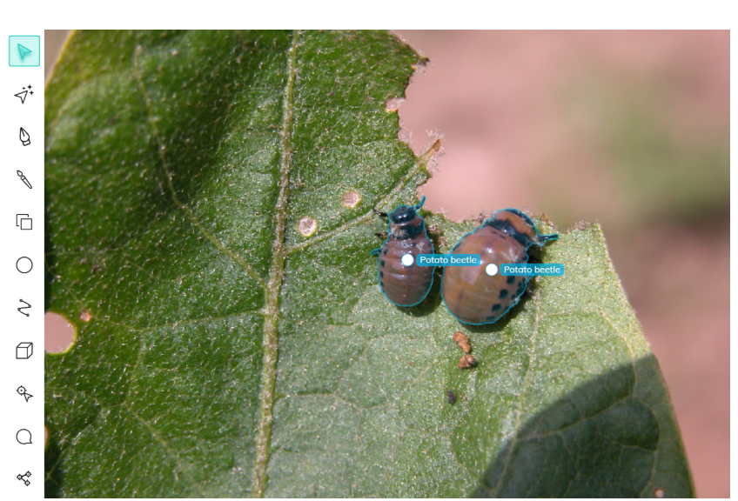
Figure,5: Computer vision system for early pest detection in crops, helping farmers protect yields with AI-powered monitoring (56).
Table 4: Showing various AI techniques, its strength and limitations in weed and pest management in agriculture.
Technique | Strength | Limitation | Reference
ANN, GA | Highly accurate and more performative. | Requires big data. | 87
Optimization using invasive weed optimization (IVO), ANN | Cost effective and enhanced performance. | Adaptation challenge with new data. | 88
Saloma expert system for evaluation, prediction and weed management | High adaptation rate and prediction level. | Requires large database and usage expertise. | 89
Support Vector Machine (SVM), ANN | Quickly detects stress in crop that will promote timely site specific remedies. | Only detect low nitrogen level in soil. | 90
Digital Image Analysis (DIA), GPS | Above 60% accuracy and success rate. | Time consuming. | 91
UAV | High rate of weed detection within a short period of time. | Highly expensive, and requires vast human expertise. | 92
Learning Vector Quantization (LVQ), ANN | High weed recognition rate with short processing time. | Data input method affected the AI performance ability. | 93
Sensor machine learning, ROBOTICS | Saves time and removes resistant weeds. | Expensive and continuous use of machine will reduce soil fertility and productivity. | 94

3.8 Drones application of AI in agriculture:
Drones, equipped with various sensors and cameras, collect detailed data about crops and fields, which can be analysed using machine learning models to gain insights into crop health, growth patterns, and identify potential issues like pests and diseases. As for example, AI-powered drones provided by FlyPix AI, Thanos Technologies, and Agremo help farmers continuously monitor crops and herds without manual observation. These platforms use high-resolution aerial imagery and advanced algorithms to automatically detect plant health issues, optimize spraying, map weeds and diseases, and track livestock, allowing farmers to identify problems early and make informed decisions while saving time and labour (95,96,97).
Benefits of Using Drones with Machine Learning in Agriculture (with Examples)
Improved crop monitoring: Using drone imagery and computer vision, Convolutional Neural Networks (CNN) models can classify crop diseases, detect nutrient deficiencies, and monitor plant growth stages. These deep learning models excel at extracting spatial features from image data for accurate real-time crop health monitoring.
For example, FlyPix AI provides agricultural drones equipped with advanced sensors and deep learning algorithms for real-time crop health analytics, weed detection, and pest management, notifying farmers instantly if problems are detected (95).
Increased efficiency: A drone flies over a large maize field collecting data on plant height and vigour. Machine learning algorithms analyse this data to predict expected yield and identify underperforming zones, enabling farmers to focus resources more effectively across vast areas in less time (96).
On the tomato front, machine learning-based image grading uses seven visual features to assess tomato quality with 95.5% accuracy. These methods reduce the need for tedious manual labour while maintaining high quality standards (98).
Reduced costs: By using drones to collect pest infestation data, machine learning models can classify and quantify pest populations in a soybean field, reducing the need for expensive manual scouting and enabling targeted pest control measures that lower pesticide usage and expenses (99).
Precise application of fertilizers, pesticides, and irrigation: For instance, Drones, also called UAVs, can find and mark the exact spots in a farm where weeds are a problem. Smart sprayer machines that use special cameras and motor controls can spot weeds by their size, shape, and where they grow, and then spray just the right amount of herbicide on them. This way, farmers use less chemicals, saving money and protecting good crops from unnecessary spray (100).
Mapping and survey: Drones gather high-resolution images of a vineyard, and machine learning-based image segmentation identifies soil erosion-prone zones and water stress areas. This information helps farmers plan better land management practices and improve crop distribution in future planting cycles (101).
3.9 Water and soil analysis applications of AI in agriculture: Soil and water are fundamental to successful agriculture, acting as the base for healthy crop growth and high productivity. Soil provides essential nutrients and water retention capacity necessary for plants, supports root systems, and hosts microorganisms that help nutrient cycling and improve soil health, ultimately boosting crop yields (101). Water plays a crucial role in transporting these nutrients to plants and maintaining their turgidity and photosynthesis, while proper soil moisture reduces soil erosion and supports beneficial microbial activity (101).
Artificial Intelligence (AI) can greatly enhance soil and water management by providing precise, data-driven insights. AI-powered systems optimize water usage in agriculture by leveraging software such as smart irrigation platforms and decision support systems that analyse real-time data from weather, soil moisture, and crop growth sensors to determine precise irrigation schedules. These tools include Farmonaut, fieldWISE, and other AI-driven platforms that integrate soil sensors, weather stations, and remote sensing data (from satellites and drones) for data-driven recommendations AI analyses historical and current data—including soil health, weather forecasts, and crop growth patterns—to recommend when and how much water to apply, making irrigation more efficient and cutting water use by up to 25% (102).
Key AI Tools and Software
Smart irrigation controllers use IoT soil moisture sensors and AI algorithms to monitor field conditions and adjust watering schedules in real time. These controllers help save water by ensuring that crops receive just the right amount they need (103).
Time-series models like Recurrent Neural Networks (RNNs) and Long Short-Term Memory (LSTM) networks analyse patterns from weather, soil moisture, and historical crop data to forecast irrigation needs. By predicting when and how much water to use, farmers can optimize water usage and increase productivity (104).
Predictive analytics platforms such as Farmonaut and fieldWISE evaluate both historical and live weather and soil data to recommend irrigation schedules, warn about drought risks, and support adaptability to climate changes (105).
Remote sensing and imaging—using drones and satellites—combined with AI can spot soil moisture differences and detect early signs of crop stress. The technology then suggests timely interventions to prevent problems before they become severe (106).
Decision Support Systems (DSS) integrate multiple types of field data, such as soil pH, nutrients, moisture levels, and crop health, to guide farmers in making informed decisions for water and soil management (107).
DSS-IWM uses crop phenology, root growth models, and weather data to estimate soil moisture and optimize irrigation planning. DSS-IWM outputs simulated crop yields and water use, helping farmers balance soil water (108).
Soil Navigator DSS AI tool assesses and advises on five soil functions, using multi-criteria decision models and expert-validated datasets. It provides a user interface for farmers to manage soil productivity, water regulation, biodiversity, and climate resilience (109).
TuplOS is an AI platform that supports automated smart irrigation and green area management, integrating sensors, IoT devices, and AI action-planning to optimize crop maintenance and water use (110).
These AI-powered solutions help farmers use water and soil resources wisely, improve crop yields, and make agriculture more sustainable (111).
Table 5. Showing various AI techniques, its strength and limitations in soil analysis for agriculture.
Technique | Strength | Limitation | Reference
Management Oriented Modeling(MOM) | Minimizes nitrate leaching, maximizes production. | Takes time and limited only to nitrogen. | 112
Decision Support System (DSS) | Can classify soil according to associated risks. | Need big data, and only few cases were studied. | 113
Fuzzy Logic SRC-DSS | Reduces soil erosion and sedimentary yield. | Requires big data. | 114
ANN | It predict soil texture. | Big data requirements and restriction in areas of implementation. | 115
ANN | Can predict monthly mean soil temperature. | Considered only temperature as a factor for soil performance. | 116
ANN | Can predict soil enzyme activity and classify soil structure. | Only measure a few soil enzymes, it considered more classification than improving the performance of the soil. | 117

4.Other application of AI in agriculture:
4.1 Livestock monitoring applications of AI in agriculture:
AI applications in livestock monitoring use machine learning algorithms and other AI techniques to collect, analyse, and interpret data from sources like cameras, sensors, and drones to monitor the health and well-being of animals (44).
Livestock Monitoring Applications with Examples and Models:
Disease detection: AI-powered disease detection systems use aerial drones (such as the DJI Matrice 300) equipped with thermal cameras to record temperature variations in livestock herds. These thermal images are analysed using convolutional neural networks (CNNs), which can detect abnormal heat patterns that indicate infections, fevers, or early disease symptoms—enabling farmers to intervene promptly (118).
Feeding and nutrition monitoring: Automatic feeding stations utilize cameras and weight sensors to log how frequently and how much animals eat. Machine learning algorithms, particularly CNNs, process this data to monitor feeding behaviours and flag anomalies—such as decreased intake, which can indicate health or reproductive problems (119).
Breeding management: AI-powered monitoring systems utilize drones such as the Parrot Anafi thermal drone to gather detailed information on livestock movement and behaviour during breeding seasons. These systems enable more precise timing for breeding by remotely detecting physiological or behavioural indicators, such as estrus, from aerial imagery and sensor data, thereby enhancing breeding outcomes and herd productivity (120).
Additionally, drones equipped with multispectral cameras and environmental sensors are used to evaluate pasture quality and map the movement of grazing livestock. AI algorithms analyse the resulting datasets to ensure that animals have ongoing access to nutritious grazing areas and optimal environmental conditions, directly supporting animal welfare and sustainable productivity (121).
4.2 Post harvest management of crops by applications of AI:
The phase that starts immediately after harvesting within the crop production cycle is called post-harvesting, which encompasses crucial activities such as handling, processing, storage, packaging, transportation, and distribution. A considerable volume of agricultural produce is often wasted during this stage due to various causes. These post-harvest losses stem from both internal and external factors including physiological deterioration, mineral deficiencies, damage caused by exposure to excessively low or high temperatures, and adverse environmental conditions. The magnitude of these losses varies significantly across regions, typically ranging from 2% to 20% in developed countries, while in less developed nations, post-harvest waste can be substantially higher, falling between 24% and 40 (122).
Real-time Monitoring and Quality Control:
IoT sensors deployed in storage facilities, transportation units, and packaging environments continuously track crucial parameters like temperature, humidity, ethylene, CO₂ levels, and spoilage indicators. The collected data is fed into AI-powered analytical systems—often built with machine learning models such as convolutional neural networks (CNNs) and artificial neural networks (ANNs)—to detect quality deviations and forecast the progression of ripening or spoilage. Technologies like Radio Frequency Identification (RFID) and IoT sensors have been developed to monitor the condition of agricultural products during transportation continuously. These systems track vital environmental variables and the status of the produce to help maintain ideal conditions throughout the supply chain. Moreover, they detect problems such as diseases, spoilage, and declining food quality, thereby enhancing food safety and minimizing losses (123).
Computer vision systems automate sorting and grading based on attributes like size, colour, and shape, increasing consistency and reducing labour costs and human error. Popular software frameworks for these tasks include TensorFlow and PyTorch, which enable deep learning for image analysis (124).
Predictive Analytics for Shelf-Life
The Fully Convolutional Networks (FCN) model achieved a high accuracy of 98.20% in detecting expiry dates on food products. A spoilage tracking system developed in 2023 utilizes machine learning algorithms to predict food deterioration by analysing attributes such as colour, texture, and odour. This system has been effective in reducing food waste by closely monitoring the freshness of perishable items (125).
Smart Storage and Logistics
A Wireless Sensor Network (WSN)-based monitoring system was developed for cold chain logistics in aquatic products, demonstrating high accuracy in collecting and transmitting environmental data essential for maintaining product quality during transportation (109). This system employs ZigBee wireless temperature sensor nodes installed in refrigerated trucks or storage facilities, which periodically gather temperature data and send it to a central network coordinator (126).
4.3 Food packaging and transportation application of AI:
The food packaging industry is undergoing a major transformation with the integration of Artificial Intelligence (AI), changing how food is packaged, distributed, and consumed. Intelligent packaging is an emerging technology designed to support decision-making while improving food quality and safety. Recent advancements in smart packaging include the use of barcode labels, RFID-enabled tags, biosensors, and indicators that monitor time, temperature, and gas levels (127).Additionally, visual sensors can assist in determining the most efficient packaging methods for irregularly shaped food items, helping to minimize the amount of plastic surface area needed for coverage (128).
Additionally, AI technologies are transforming on-farm food handling by enabling automated sorting and transport systems. Intelligent vision systems now identify and separate contaminated, damaged, or overripe produce directly in the field, classifying items based on attributes such as size, colour, and maturity (129). Once sorted, bins or trays are autonomously transported from the picking sites to designated collection points using AI-guided vehicles or robotic carriers. These systems optimize on-farm logistics, ensuring efficient movement of produce to centralized collection or packing areas. In large-scale agricultural operations, factory-level sorting lines equipped with AI algorithms further streamline grading and packaging, enhancing both speed and product quality (130).
The integration of computer vision and machine learning into on-farm sorting and transportation helps minimize post-harvest losses by enhancing the accuracy and efficiency of these processes (131).
4.4 Applications of AI in plant breeding:
Plant breeding is widely recognized as a key strategy for combating global hunger and is considered one of the most effective approaches for improving future food security. In recent years, it has been used to create new crop varieties that offer increased productivity and greater resilience to environmental stresses, diseases, and pests (132).
To overcome these challenges, genomic selection is extensively applied in plant breeding, utilizing DNA markers to estimate the genetic potential and breeding value of plants (133).
A key part of breeding is studying plant traits such as growth rate, yield potential, and resistance to disease. Several machine learning algorithms, including Support Vector Machines (SVM), Random Forests (RF), and Gradient Boosting, have been utilized in breeding populations to predict complex genetic traits. (134).
Various machine learning algorithms are used in plant disease detection, such as SVM for analysing thermal, light, and fluorescence imaging spectroscopy data, SAM for interpreting remote sensing imagery, and ANN for processing RGB images (135).
Artificial intelligence is also integrated into decision support systems to improve and forecast breeding strategies and hybrid performance. Tools like the Genomic Selection Decision Support Tool (GS-DST) are used to estimate breeding values (136).
Climate change poses significant challenges for plant breeders, and AI offers considerable promise in addressing these issues by enhancing climate-resilient traits. Techniques such as Random Forests (RF), Support Vector Machines (SVM), and neural networks, combined with multi-omics data—including genomics, transcriptomics, proteomics, and phenomics—enable the identification and selection of high-quality breeding lines with improved tolerance to extreme environmental conditions (137).
To identify superior genotypes and evaluate their tolerance or resistance, several methods are applied. By combining traditional machine learning approaches with deep convolutional neural networks (CNN), crop stress and plant diseases can be detected with around 95% accuracy. When integrated with imaging techniques, machine learning can simulate and forecast how different genotypes respond to stress, as well as predict which variants will show greater resilience under both stress and non-stress conditions (138). The integration of genomic and phenomic data with machine learning, tools like Artificial Neural Networks (ANN) are highly effective tools for such analyses. They have shown strong performance in studying factors such as atmospheric pressure, precipitation, temperature, and crop diseases, with Multilayer Perceptron ANN (MLP-ANN) being particularly successful (139). Conducting detailed investigations into gene action related to phenology, morphology, and yield component traits is essential for determining the heritability within crossbreeding programs. Accurate prediction of optimal parental combinations is vital for selecting superior hybrid varieties, and machine learning-assisted ANN models can provide valuable insights into parental genetic blends, enabling the development of high-performing breeds (140).
Another way AI speeds up breeding is through simulations. Instead of waiting years for new varieties to develop, AI can simulate plant growth under different conditions and predict genetic outcomes (141).
AI also works hand-in-hand with CRISPR gene-editing technology. CRISPR allows scientists to make precise changes in plant DNA, and AI improves this by predicting the results of edits and choosing the best target sites in the genome. This reduces mistakes and ensures that only the intended traits are introduced (142).

5.Benefit and challenges of AI in Agriculture
5.1.Benefit
Artificial Intelligence (AI) is revolutionizing the agricultural industry by offering farmers advanced tools that support data-driven decision-making and automation. These technologies are helping farmers overcome traditional challenges and significantly improve the way farms are managed. Below are some of the key benefits AI brings to agriculture:
5.1.1 Increased Efficiency:
In addition, AI systems reduce the need for manual labour, which in turn lowers labour costs—a major expense in farming. Technologies like autonomous tractors, drones, and robotic harvesters can perform tasks quickly and accurately, increasing overall productivity on the farm.
Moreover, AI enables precision agriculture, which involves using sensors and data analytics to determine the exact needs of crops and animals. AI systems analyse data from satellite images, soil sensors, and weather forecasts to help farmers apply resources—such as water, fertilizer, and pesticides—more accurately and efficiently. This targeted approach reduces waste, conserves resources, and maximizes the return on investment (43).
5.1.2. Enhanced Productivity:
By using AI for real-time monitoring and decision-making, farmers can respond quickly to changing conditions, which helps ensure better outcomes for both crops and animals. AI also promotes the efficient use of inputs by applying only what is needed and when it’s needed—helping crops grow optimally while reducing the risk of overuse and environmental damage (56).

5.1.3. Sustainability:
Sustainability is a critical concern in modern agriculture, and AI supports this goal by promoting environmentally friendly practices. AI helps reduce the excessive use of water, chemicals, and fuel—resources that are often overused in traditional farming methods (52).
Smart irrigation systems powered by AI analyse soil moisture levels and weather forecasts to determine when and how much water crops need. This prevents overwatering and preserves water resources. AI systems detect pest infestations or nutrient deficiencies early, enabling targeted treatment rather than blanket spraying (49).
Furthermore, AI can help reduce the carbon footprint of farming. For instance, autonomous machinery and optimized logistics can lower fuel consumption, while data-driven practices support carbon sequestration and biodiversity preservation through better land use and conservation techniques (45).
5.1.4. Data-Driven Decisions:
Perhaps the most powerful aspect of AI in agriculture is its ability to process vast amounts of data and convert it into actionable insights. With access to real-time data from sensors, drones, satellites, and weather stations, farmers can make informed decisions based on accurate, up-to-date information (54). AI tools can continuously monitor crop health, detect diseases or pest threats early, and provide alerts or recommendations for treatment. AI can also analyse market trends, demand forecasts, and pricing data to help farmers decide what to grow, when to sell, and how to optimize profits (54).
5.2.Challenges
Here is an in-depth look at the most common and emerging challenges:
5.2.1. High Initial Investment Costs:
AI technologies in agriculture demand significant upfront investment, including costs for autonomous tractors, smart sensors, drones, and machine learning platforms. Small and medium-sized farms, especially in developing countries, often struggle to afford these systems due to limited financial resources for purchase and maintenance. The return on investment may take several growing seasons to become apparent, as improvements in yield or cost savings are not immediate. Limited access to loans, subsidies, or other financing options further restricts adoption. (143).
5.2.2. Data Privacy and Security Concerns:
The increasing digitization of farming operations introduces critical data privacy and security risks. Farmers generate large volumes of valuable yet sensitive data related to soil quality, crop yields, weather patterns, and farming practices. This data, often stored on cloud platforms or shared with technology providers, risks unauthorized access, misuse, or even exploitation by third parties (144).
5.2.3. Limited Technical Expertise:
Many farmers, particularly in rural areas and older age groups, face difficulties using AI technologies due to limited digital literacy and technical skills. These tools require abilities such as data interpretation, software navigation, and device management, which may be unfamiliar to those relying on traditional farming practices. Without targeted training and continued support, adoption can be slow or ineffective, reducing the potential benefits (145).

5.2.4. Integration with Existing Systems and Equipment:
Many farms rely on legacy equipment that is often incompatible with modern AI technologies, making integration both complex and expensive. Upgrading or replacing machinery requires considerable investment and expertise, while interoperability issues between different devices or platforms can hinder seamless adoption (145).
5.2.5. Connectivity and Infrastructure Gaps:
Reliable internet access, stable electricity, and robust mobile networks are essential for operating AI systems, especially those reliant on cloud computing and real-time data. However, many rural and remote agricultural areas suffer from weak or non-existent internet connectivity and frequent power outages. These infrastructure gaps disrupt AI system performance and can cause data loss or delays, disproportionately impacting farmers in low-income and developing regions. Such challenges widen the digital divide, limiting these farmers' ability to benefit from advanced technologies (146).
5.2.6. Lack of Standardization and Regulation:
The rapid advancement of AI in agriculture has outpaced the development of standardized practices and regulatory frameworks. Currently, no universal benchmarks exist to assess the effectiveness, accuracy, or safety of AI tools in farming (147).
5.2.7. Ethical and Social Considerations:
The integration of AI in agriculture raises ethical concerns such as potential job displacement due to automation reducing the need for manual labour, diminished farmer autonomy as reliance on AI recommendations may limit independent decision-making, and bias in AI models where unrepresentative training data can lead to unequal outcomes favouring specific regions or crops (147).
5.2.8. Cultural Resistance and Trust Issues:
In many communities, especially where traditional farming practices are deeply rooted, there may be resistance to adopting new technologies. Farmers may be skeptical of AI’s accuracy or question its relevance to their specific needs. Past experiences with failed tech implementations or lack of personalized support can create hesitation (148).
6.Future Trends and Developments in AI for Agriculture:
Emerging technologies in agriculture encompass advanced machine learning and predictive analytics that analyze vast datasets from weather, satellite imagery, soil sensors, and crop health indicators to enhance yield forecasting, enable real-time disease detection, optimize planting and harvesting schedules, and predict pest and weed outbreaks. This leads to more precise, adaptive farming practices that reduce risks and improve outcomes. Additionally, the integration of AI with the Internet of Things (AIoT) is fostering intelligent farm ecosystems where smart sensors continuously monitor soil and animal health, drones and autonomous vehicles accurately survey crops and apply inputs, and connected machinery offers centralized, real-time management of farm operations. This interconnected system boosts operational efficiency and advances precision agriculture through optimized resource use and increased productivity (149).
Efforts to improve accessibility and inclusivity in AI for agriculture focus on creating affordable, scalable solutions tailored to the needs of smallholder farms and diverse regional conditions. Critical components include education and training programs, as well as expanded rural connectivity to help farmers effectively adopt and maintain AI technologies. Policymakers and industry leaders support this through investments in technology sharing, capacity building, and cooperative models that facilitate knowledge exchange (150).
7.Case studies and real-world example:
Artificial intelligence has proven highly effective in transforming agriculture by enhancing productivity and sustainability across various regions. For instance, a field study in California applied AI technologies to optimize nitrogen application and irrigation scheduling in vineyards. This innovation resulted in a 25% boost in grape yield alongside a 20% reduction in water usage (151). Likewise, in India, AI-based predictive models have been employed to determine ideal sowing periods and recommend appropriate crop varieties by analysing climatic trends, soil characteristics, and market dynamics. These implementations have substantially improved yields, optimized resource utilization, and elevated farmers’ economic returns (152). Such evidence illustrates the profound impact of AI on reshaping modern agriculture. By facilitating data-driven decision-making, AI enhances productivity, supports efficient resource management, reduces input expenditures, and minimizes environmental degradation. As digital integration accelerates globally, AI adoption in agriculture will be instrumental in meeting rising food demands, advancing sustainability, and ensuring long-term resilience and profitability for farming communities (45).
7.1World-wide: case studies:
John Deere: Global Leader in Precision Farming
John Deere has transformed modern farming through the integration of artificial intelligence, machine learning, and edge computing in its autonomous tractors and combine harvesters. These advanced machines, equipped with high-precision sensors and real-time analytics, gather and process detailed data on soil conditions, crop health, and field activities. The resulting AI-driven insights enable highly targeted irrigation, fertilization, and pesticide application, leading to improved resource efficiency, increased yields, and reduced environmental impact. This intelligent ecosystem further enhances farm operations through cloud-based management platforms and remote monitoring capabilities, allowing farmers to optimize productivity, lower costs, and strengthen sustainability (153).
Plantix: Empowering Smallholder Farmers in India
The Plantix mobile application, developed by PEAT, utilizes artificial intelligence and image recognition technology to accurately detect crop diseases from images captured on smartphones. Through advanced machine learning models, it identifies pests, nutrient deficiencies, and various plant diseases, providing farmers with immediate and practical treatment recommendations. By enabling early detection and targeted responses, the app helps minimize chemical inputs while improving crop health and productivity (55).
The Climate Corporation: AI for Irrigation Optimization
The Climate Field-View platform, developed by Bayer’s subsidiary The Climate Corporation, integrates weather forecasting, field measurements, soil data, and machine learning analytics to provide farmers with highly accurate irrigation recommendations. By tailoring guidance to anticipated environmental conditions, the system enables more efficient water usage and lowers irrigation-related expenses. This approach not only conserves water and reduces energy consumption but also supports sustained crop health, making it especially valuable in areas where water resources are limited (154).

Monsanto/Bayer: Accelerating Crop Breeding
Monsanto, now a part of Bayer, applies artificial intelligence alongside CRISPR gene-editing technology to analyse extensive genomic datasets and identify genes associated with desirable traits such as drought tolerance and pest resistance (155).
Cainthus: Livestock Monitoring with Computer Vision
Cainthus utilizes artificial intelligence-driven computer vision systems to continuously monitor livestock health, feeding behavior, and activity patterns in real time. Cameras positioned within barns capture live video feeds that are analysed by advanced algorithms capable of identifying early indicators of illness and assessing overall animal well-being. (156).
7.2 India-Specific Case Studies:
Microsoft & ICRISAT: AI for Sowing and Yield Prediction
Microsoft and ICRISAT have partnered to deploy AI-driven advisory services for Indian farmers. These tools analyse weather, soil, and crop data to recommend optimal sowing times and crop varieties, resulting in increased yields and efficient resource use (157).
Fasal: AI-Powered IoT in Horticulture
Indian startup Fasal offers AI-powered IoT solutions that monitor micro-climatic conditions, soil moisture, and crop health, delivering precise, actionable advice on irrigation, fertilization, and harvest timing directly through mobile platforms. This site-specific guidance enables farmers to optimize water use and enhance crop quality, leading to more efficient resource management and improved agricultural outcomes (158).
CropIn: Data Analytics for Smart Farming
CropIn, an agri-tech company, employs AI and advanced analytics to help farmers visualize and optimize their field operations. Utilizing image data from satellites and smartphones, CropIn supports disease diagnosis, yield estimation, and compliance management (159).

9.Conclusion:
The use of artificial intelligence (AI) supports farmers in optimizing fertilizer and crop selection by leveraging interconnected systems that analyse user-provided data to identify the most suitable crops for harvesting and fertilizers that promote optimal growth. AI is fundamentally transforming agriculture by improving the quality of agricultural products. Significant advances in deep learning (DL) have expanded AI applications, while the Internet of Things (IoT) aids real-time data monitoring. AI-driven solutions such as smart irrigation, yield forecasting, post-harvest management, and on-farm sorting increase productivity, reduce waste, and enhance crop yields. Additionally, AI enables early identification of diseases and pests, precise pesticide application, and ongoing soil health monitoring, fostering sustainable and productive farming practices. As AI technology advances, it holds substantial promise for addressing global challenges related to food security and sustainability by boosting agricultural productivity, resilience, and efficiency.
Reference:

Reference:
- Ahmed, N., De, D., & Hussain, I. (2018). Internet of Things (IoT) for smart precision agriculture and farming in rural areas. IEEE internet of things journal, 5(6), 4890-4899.
- Arjun, K. M. (2013). Indian agriculture-status, importance and role in Indian economy. International Journal of Agriculture and Food Science Technology, 4(4), 343-346.
- Statista. (2024, March 15). Agriculture in India — statistics & facts. Statista. https://www.statista.com/topics/4868/agricultural-sector-in-india/
- TheGlobalEconomy.com. (2025). China: GDP share of agriculture [Data set]. Retrieved from https://www.theglobaleconomy.com/China/share_of_agriculture/
- Chowdhuri, I., & Pal, S. C. (2025). Challenges and potential pathways towards sustainable agriculture crop production: A systematic review to achieve sustainable development goals (SDGs). Soil and Tillage Research, 248, 106442.
- Falcon, W. P., Naylor, R. L., & Shankar, N. D. (2022). Rethinking global food demand for 2050. Population and Development Review, 48(4), 921-957.
- Tilman, D., Balzer, C., Hill, J., & Befort, B. L. (2011). Global food demand and the sustainable intensification of agriculture. Proceedings of the national academy of sciences, 108(50), 20260-20264.
- Godfray, H. C., & Garnett, T. (2014). Food security and sustainable intensification. Philosophical Transactions of the Royal Society B: Biological Sciences, 369(1639).
- Somov, A., Shadrin, D., Fastovets, I., Nikitin, A., Matveev, S., Seledets, I., & Hrinchuk, O. (2018). Pervasive agriculture: IoT-enabled greenhouse for plant growth control. IEEE Pervasive Computing, 17(4), 65–75.
- Abbas Khan, M., Khan, H., Omer, M. F., Ullah, I., & Yasir, M. (2024). Impact of artificial intelligence on the global economy and technology advancements. In Artificial General Intelligence (AGI) Security: Smart Applications and Sustainable Technologies (pp. 147-180). Singapore: Springer Nature Singapore.
- .Syrquin, M. (1988). Patterns of structural change. Handbook of development economics, 1, 203-273.
- McCarthy, J., Minsky, M. L., Rochester, N., & Shannon, C. E. (2006). A proposal for the dartmouth summer research project on artificial intelligence, august 31, 1955. AI magazine, 27(4), 12-12.
- Jung, J., Maeda, M., Chang, A., Bhandari, M., Ashapure, A., & Landivar-Bowles, J. (2021). The potential of remote sensing and artificial intelligence as tools to improve the resilience of agriculture production systems. Current Opinion in Biotechnology, 70, 15-22.
- Ampatzidis, Y., Partel, V., & Costa, L. (2020). Agroview: Cloud-based application to process, analyze and visualize UAV-collected data for precision agriculture applications utilizing artificial intelligence. Computers and Electronics in Agriculture, 174, 105457.
- Javaid, M., Haleem, A., Khan, I. H., & Suman, R. (2023). Understanding the potential applications of Artificial Intelligence in Agriculture Sector. Advanced Agrochem, 2(1), 15-30.
- Markovate. (n.d.). Predictive AI: Forecasting the future and unlocking insights. Retrieved September 13, 2025, from https://markovate.com/blog/predictive-ai/
- IBM. (2023, July 5). AI vs. machine learning vs. deep learning vs. neural networks. IBM. https://www.ibm.com/think/topics/ai-vs-machine-learning-vs-deep-learning-vs-neural-networks
- Lagos, I., Atinuke, O. M., & Wosilat, O. Y. E. N. I. Y. I. Artificial Intelligence Teamwork for Agricultural Information Service Delivery in a Changing World: a Paradigm Shift.
- Dhingra, S., Dhingra, A. K., & Gupta, S. B. (2022). Smart farming: An IOT based automation. In Ambient Communications and Computer Systems: Proceedings of RACCCS 2021 (pp. 79-88). Singapore: Springer Nature Singapore.
- Brilhador, A., Gutoski, M., Hattori, L. T., Inácio, A. D. S., Lazzaretti, A. E., & Lopes, H. S. (2019, November 11–15). Classification of weeds and crops at the pixel-level using convolutional neural networks and data augmentation. In 2019 IEEE Latin American Conference on Computational Intelligence (LA-CCI) (pp. 1–6). Guayaquil, Ecuador.
- Gupta, S. B. (2024). Artificial intelligence in smart agriculture: Applications and challenges. Current Applied Science and Technology, e0254427-e0254427.
- Nicolas, C., Naila, B., & Amar, R. C. (2022). TinyML smart sensor for energy saving in internet of things precision agriculture platform. In Thirteenth International Conference on Ubiquitous and Future Networks (ICUFN) (pp. 256-259). Barcelona, Spain, July 5-8, 2022.
- Stevanato, L., Baroni, G., Cohen, Y., Fontana, C. F., Gatto, S., Lunardon, M., Marinello, F., Moretto, S., & Morselli, L. (2019). A novel cosmic-ray neutron sensor for soil moisture estimation over large areas. Agriculture, 9(9). https://doi.org/10.3390/agriculture9090202
- Juan, M., Jurado, López, A., Pádua, L., & Sousa, J. (2022). Remote sensing image fusion on 3D scenarios: A review of applications for agriculture and forestry. International Journal of Applied Earth Observation and Geoinformation, 112. https://doi.org/10.1016/j.jag.2022.102856
- Anastasiou, E., Balafoutis, A. T., & Fountas, S. (2023). Trends in remote sensing technologies in olive cultivation. Smart Agricultural Technology, 3. https://doi.org/10.1016/j.atech.2022.100103
- Elijah, O., Rahman, T. A., Orikumhi, I., Leow, C. Y., & Hindia, M. N. (2018). An overview of internet of things (IoT) and data analytics in agriculture: Benefits and challenges. IEEE Internet of Things Journal, 5(5). https://doi.org/10.1109/JIOT.2018.2844296
- Pathmudi, V. R., Khatri, N., Kumar, S., Abdul-Qawy, A. S. H., & Vyas, A. K. (2023). A systematic review of IoT technologies and their constituents for smart and sustainable agriculture applications. Scientific African, 19. https://doi.org/10.1016/j.sciaf.2023.e01577
- Hu, Z., Xu, L., Cao, L., Liu, S., Luo, Z., Wang, J., Li, X., & Wang, L. (2019). Application of non-orthogonal multiple access in wireless sensor networks for smart agriculture. IEEE Access, 7, 87582–87592. https://doi.org/10.1109/ACCESS.2019.2924917
- Debauche, O., Mahmoudi, S., Manneback, P., & Lebeau, F. (2022). Cloud and distributed architectures for data management in agriculture 4.0: Review and future trends. Journal of King Saud University - Computer and Information Sciences, 34(9), 7494-7514. https://doi.org/10.1016/j.jksuci.2021.09.015
- Cravero, A., Pardo, S., Sepúlveda, S., & Muñoz, L. (2022). Challenges to use machine learning in agricultural big data: A systematic literature review. Agronomy, 12(3), 748.
- Mi, C., Peng, X., Peng, L., Zhao, C., & Deng, X. (2021). Research on crop disaster stress risk mapping system based on agriculture big data. In 2021 International Conference on Electronic Information Technology and Smart Agriculture (ICEITSA) (pp. 525-530). Huaihua, China, December 10-12, 2021.
- Cravero, S., & Sepulveda, A. (2021). Use and adaptations of machine learning in big data applications in real cases in agriculture. Electronics, 10(5). https://doi.org/10.3390/electronics10050552
- Dhanya, V. G., Subeesh, A., Kushwaha, N. L., Vishwakarma, D. K., Kumar, T. N., Ritika, G., Singh, & Dinesh, K. (2022). Deep learning based computer vision approaches for smart agricultural applications. Artificial Intelligence in Agriculture, 6, 211-229. https://doi.org/10.1016/j.aiia.2022.09.007.
- Jin, X., Zhang, J., Kong, J., Su, T., & Bai, Y. A. (2022). A reversible automatic selection normalization (RASN) deep network for predicting in the smart agriculture system. Agronomy, 12. https://doi.org/10.3390/agronomy12030591
- Zhai, Z., Martinez, J. F., Beltran, V., & Martinez, N. L. (2020). Decision support system for agriculture 4.0: Survey and challenges. Computers and Electronics in Agriculture, 170. https://doi.org/10.1016/j.compag.2020.105256
- Recio, B., Rubio, F., & Criado, J. A. (2003). A decision support system for farm planning using AgriSupport II. Decision Support Systems, 36, 189-203. https://doi.org/10.1016/S0167-9236(02)00134-3
- Khan, A. A., Laghari, A. A., & Awan, S. A. (2021). Machine learning in computer vision: A review. EAI Endorsed Transactions on Scalable Information Systems, 8(32).
- Khan, A. I., & Al-Habsi, S. (2020). Machine learning in computer vision. Procedia Computer Science, 167, 1444-1451.
- Singh, A. K., Verma, R., Singh, B., & Singh, M. S. The Role of Artificial Intelligence in Agriculture: A Comprehensive.
- Akintuyi, O. B. (2024). AI in agriculture: A comparative review of developments in the USA and Africa. Research Journal of Science and Engineering, 10(02), 060-070.
- Padhiary, M., Saha, D., Kumar, R., Sethi, L. N., & Kumar, A. (2024). Enhancing precision agriculture: A comprehensive review of machine learning and AI vision applications in all-terrain vehicle for farm automation. Smart Agricultural Technology, 8, 100483.
- Talaviya, T., Shah, D., Patel, N., Yagnik, H., & Shah, M. (2020). Implementation of artificial intelligence in agriculture for optimisation of irrigation and application of pesticides and herbicides. Artificial intelligence in agriculture, 4, 58-73.
- Espinel, R., Herrera-Franco, G., Rivadeneira García, J. L., & Escandón-Panchana, P. (2024). Artificial intelligence in agricultural mapping: A review. Agriculture, 14(7), 1071.
- AgriFarming. (n.d.). 10 practical applications of AI in agriculture: Impacts and benefits of crop health and yield. Retrieved September 14, 2025, from https://www.agrifarming.in/10-practical-applications-of-ai-in-agriculture-impacts-and-benefits-of-crop-health-and-yield.
- Aijaz, N., Lan, H., Raza, T., Yaqub, M., Iqbal, R., & Pathan, M. S. (2025). Artificial intelligence in agriculture: Advancing crop productivity and sustainability. Journal of Agriculture and Food Research, 101762.
- Balafoutis, A., Beck, B., Fountas, S., Vangeyte, J., Van der Wal, T., Soto, I., ... & Eory, V. (2017). Precision agriculture technologies positively contributing to GHG emissions mitigation, farm productivity and economics. Sustainability, 9(8), 1339.
- Ercan Oğuztürk, G., Murat, C., Yurtseven, M., & Oğuztürk, T. (2025). The Effects of AI-Supported Autonomous Irrigation Systems on Water Efficiency and Plant Quality: A Case Study of Geranium psilostemon Ledeb. Plants, 14(5), 770.
- Leukel, J., Zimpel, T., & Stumpe, C. (2023). Machine learning technology for early prediction of grain yield at the field scale: A systematic review. Computers and Electronics in Agriculture, 207, 107721.
- Jeong, J. H., Resop, J. P., Mueller, N. D., Fleisher, D. H., Yun, K., Butler, E. E., ... & Kim, S. H. (2016). Random forests for global and regional crop yield predictions. PloS one, 11(6), e0156571.
- Sun, J., Di, L., Sun, Z., Shen, Y., & Lai, Z. (2019). County-level soybean yield prediction using deep CNN-LSTM model. Sensors, 19(20), 4363.
- Yang, W., Nigon, T., Hao, Z., Paiao, G. D., Fernández, F. G., Mulla, D., & Yang, C. (2021). Estimation of corn yield based on hyperspectral imagery and convolutional neural network. Computers and Electronics in Agriculture, 184, 106092
- Qiao, M., He, X., Cheng, X., Li, P., Luo, H., Zhang, L., & Tian, Z. (2021). Crop yield prediction from multi-spectral, multi-temporal remotely sensed imagery using recurrent 3D convolutional neural networks. International Journal of Applied Earth Observation and Geoinformation, 102, 102436.
- Nevavuori, P., Narra, N., Linna, P., & Lipping, T. (2020). Crop yield prediction using multitemporal UAV data and spatio-temporal deep learning models. Remote sensing, 12(23), 4000.
- Eli-Chukwu, N. C. (2019). Applications of artificial intelligence in agriculture: A review. Engineering, Technology & Applied Science Research, 9(4).
- Balleda, K., Satyanvesh, D., Sampath, N. V. S. S. P., Varma, K. T. N., & Baruah, P. K. (2014, January). Agpest: An efficient rule-based expert system to prevent pest diseases of rice & wheat crops. In 2014 IEEE 8th International Conference on Intelligent Systems and Control (ISCO) (pp. 262-268). IEEE.
- Rizzoli, A. (2021, October 12). AI in Agriculture: 8 Practical Applications [2024 Update]. V7 Labs. Retrieved September 14, 2025, from https://www.v7labs.com/blog/ai-in-agriculture.
- India - Israel Trade & Economic Office, Embassy of Israel. (2024, May 6). AI in Israeli agriculture. Retrieved September 14, 2025, from https://itrade.gov.il/india/2024/05/06/ai-in-israeli-agriculture/#:~:text=Startups%20such%20as%20Taranis%20and%20Prospera%20are%20pioneering,health%2C%20soil%20conditions%2C%20and%20weather%20patterns%20in%20real-time
- Ye, Z., Yin, S., Cao, Y., & Wang, Y. (2024). AI-driven optimization of agricultural water management for enhanced sustainability. Scientific Reports, 14(1), 25721.
- al Bakri, K. Z. S., Al Flaiti, M. K. S., Al-Balushi, S. A. S., & Poorngalingam, J. (2024). Revolutionizing agriculture: Harnessing the power of artificial intelligence for sustainable farming practices.
- Plant, R. E. (1989). An artificial intelligence -based method for scheduling crop management actions. Agricultural systems, 31(1), 127-155.
- Lal, H., Jones, J. W., Peart, R. M., & Shoup, W. D. (1992). FARMSYS—a whole-farm machinery management decision support system. Agricultural systems, 38(3), 257-273.
- Dahikar, S. S., & Rode, S. V. (2014). Agricultural crop yield prediction using artificial neural network approach. International journal of innovative research in electrical, electronics, instrumentation and control engineering, 2(1), 683-686.
- Song, H., & He, Y. (2005, July). Crop nutrition diagnosis expert system based on artificial neural networks. In Third International Conference on Information Technology and Applications (ICITA'05) (Vol. 1, pp. 357-362). IEEE.
- Papageorgiou, E. I., Markinos, A. T., & Gemtos, T. A. (2011). Fuzzy cognitive map based approach for predicting yield in cotton crop production as a basis for decision support system in precision agriculture application. Applied Soft Computing, 11(4), 3643-3657.
- Yang, C. C., Prasher, S. O., Landry, J. A., & Ramaswamy, H. S. (2003). Development of a herbicide application map using artificial neural networks and fuzzy logic. Agricultural systems, 76(2), 561-574.
- Ji, B., Sun, Y., Yang, S., & Wan, J. (2007). Artificial neural networks for rice yield prediction in mountainous regions. The Journal of Agricultural Science, 145(3), 249-261.
- Farmonaut. (2025). AI Disease Prediction & Weather Tools For Crop Detection. Retrieved September 14, 2025, from https://farmonaut.com/precision-farming/ai-disease-prediction-weather-tools-for-crop-detection-2025.
- Microsoft Research. (2024). FarmBeats: AI, Edge & IoT for Agriculture. Retrieved September 14, 2025, from https://www.microsoft.com/en-us/research/project/farmbeats-iot-agriculture/
- Tomorrow.io. (2025). Agriculture weather solutions. Retrieved from https://www.tomorrow.io/solutions/agriculture/
- Auravant. (n.d.). Auravant. Retrieved 2025, from https://auravant.com/
- The Climate Corporation. (2025). Climate FieldView: Maximize results with our digital farming solution. Retrieved September 14, 2025, from https://climate.com/
- Hosseini, M. (2024, October 14). Predictive maintenance in agriculture: Equipment longevity & resource utilization. Arshon Technology. https://arshon.com/blog/predictive-maintenance-in-agriculture-equipment-longevity-resource-utilization/
- Digital Arena. (2025). IBM Maximo EAM & Predictive Maintenance. Retrieved September 14, 2025, from https://www.digitalarenas.net/products/asset-life-cycle.
- Intangles. (2025, March 28). From tractors to tech: AI & IoT transforming farm equipment management. Intangles. https://www.intangles.ai/from-tractors-to-tech-ai-iot-transforming-farm-equipment-management.
- Autogrow. (n.d.). MultiGrow - Greenhouse climate controller. Retrieved September 14, 2025, from https://autogrow.com/products/multigrow
- Cao, X., Yao, Y., Li, L., Zhang, W., An, Z., Zhang, Z., Xiao, L., Guo, S., Cao, X., Wu, M., & Luo, D. (2021). iGrow: A smart agriculture solution to autonomous greenhouse control. arXiv. https://arxiv.org/abs/2107.05464
- LetsGrow.com. (2023, January 23). From traditional growing towards growing without hands. Retrieved September 14, 2025, from https://www.letsgrow.com/our-world/from-traditional-growing-towards-growing-without-hands/
- GreenIQ. (2015, May 4). GreenIQ's smart garden hub is like a nest for gardens. Digital Trends. Retrieved September 14, 2025, from https://www.digitaltrends.com/home/greeniqs-smart-garden-hub-is-like-a-nest-for-gardens/
- Zimdahl, R. L. (1992). Weed impact on wheat, maize, and other temperate crops. Proc. lst Intern. Weed Control Congr, 1, 118-122.
- Horvath, D. P., Clay, S. A., Swanton, C. J., Anderson, J. V., & Chao, W. S. (2023). Weed-induced crop yield loss: a new paradigm and new challenges. Trends in Plant Science, 28(5), 567-582.
- Ahmed, S., Salim, M., & Chauhan, B. S. (2014). Effect of weed management and seed rate on crop growth under direct dry seeded rice systems in Bangladesh. PloS one, 9(7), e101919.
- Sujithra, P., Hemalatha, M., Joseph, M., & Sobhana, E. (2019). Effect of different weed management practices on growth and yield of rainfed sesame (Sesamum indicum L.) under vertisol.
- Effect of weed management practices on seed yield and nutrient uptake of sesame. Indian Journal of Agricultural Research.
- Kiran, B., & Rana, C. (2025). Artificial Intelligence in Agriculture: A Comprehensive Review of Applications, Challenges, and Future Prospects. International Journal of Sciences and Innovation Engineering, 2(6), 674-690.
- StartUs Insights. (2025). AI in agriculture: A strategic guide [2025–2030]. Retrieved September 14, 2025, from https://www.startus-insights.com/innovators-guide/ai-in-agriculture-strategic-guide/
- Aziz, D., Rafiq, S., Saini, P., Ahad, I., Gonal, B., Rehman, S. A., ... & Nabila Iliya, M. (2025). Remote sensing and artificial intelligence: revolutionizing pest management in agriculture. Frontiers in Sustainable Food Systems, 9, 1551460.
- Tobal, A., & Mokhtar, S. A. (2014). Weeds identification using Evolutionary Artificial Intelligence Algorithm. J. Comput. Sci., 10(8), 1355-1361.
- Branch, M. (2012). A multi layer perceptron neural network trained by invasive weed optimization for potato color image segmentation. Trends Appl. Sci. Res, 7(6), 445-455.
- Moallem, P., Razmjooy, N., & Ashourian, M. (2013). Computer vision-based potato defect detection using neural networks and support vector machine. International Journal of Robotics and Automation, 28(2), 137-145.
- Stigliani, L., & Resina, C. (1993). SELOMA: expert system for weed management in herbicide-intensive crops. Weed Technology, 7(3), 550-559.
- Gerhards, R., & Christensen, S. (2003). Real‐time weed detection, decision making and patch spraying in maize, sugarbeet, winter wheat and winter barley. Weed research, 43(6), 385-392.
- López‐Granados, F. (2011). Weed detection for site‐specific weed management: mapping and real‐time approaches. Weed Research, 51(1), 1-11.
- Yang, C. C., Prasher, S. O., Landry, J., & Ramaswamy, H. S. (2002). Development of neural networks for weed recognition in corn fields. Transactions of the ASAE, 45(3), 859.
- Brazeau, M. (2018). Fighting weeds: can we reduce, or even eliminate, herbicides by utilizing robotics and AI. Genetic Literacy Project, North Wales.
- FlyPix AI. (2024). Agriculture drone companies: Transforming farming with AI. Retrieved September 14, 2025, from https://flypix.ai/blog/agriculture-drone-companies
- Thanos Technologies. (2024). Using AI-powered drones to transform modern crop monitoring and farm management. http://thanos.in
- Agremo. (2025). Field analytics software & precision agriculture. Retrieved September 14, 2025, from https://www.agremo.com
- Vazquez, D. V., do Amaral, J. G. C., de Souza, R. T., Ribeiro, M. H., Velloso, C. M., & Rodrigues, F. A. (2024). Machine learning-based tomato fruit shape classification improves accuracy and reduces manual labor in grading. Frontiers in Plant Science, 15, Article 11397308. https://pmc.ncbi.nlm.nih.gov/articles/PMC11397308.
- Park, Y. L., Kim, J., Lee, H., Choi, S., & Kwon, T. (2023). Rapid assessment of insect pest outbreak using drones. Frontiers in Plant Science, 13, 10299355.
- Sandoval-Pillajo, L., García-Santillán, I., Pusdá-Chulde, M., & Giret, A. (2025). Weed Detection Based on Deep Learning from UAV Imagery: A Review. Smart Agricultural Technology, 101147.
- Zuta, A. (2020). Evaluation of water stress mapping methods in vineyards using airborne thermal imaging (Master’s thesis, Lund University, Sweden). Lund University.
- Farmonaut. (2025). Soil fertility & water: Keys to agricultural success. Retrieved from https://farmonaut.com/precision-farming/soil-and-water-5-keys-to-agricultural-success.
- Keymakr. (2024, August 21). Precision irrigation: How AI can optimize water usage in agriculture. Retrieved from https://keymakr.com/blog/precision-irrigation-how-ai-can-optimize-water-usage-in-agriculture/
- RTS Labs. (2024, October 25). AI-powered farming: Harnessing soil, water, and climate data to empower farmers. Retrieved from https://rtslabs.com/ai-powered-farming rtslabs.com.
- AZoRobotics. (2025, February 14). Artificial intelligence (AI) in soil quality monitoring. Retrieved from https://www.azorobotics.com/Article.aspx?ArticleID=482.
- Phycoterra. (2025). How soil health impacts your farm’s water. Retrieved from https://phycoterra.com/blog/how-soil-health-impacts-your-farms-water/
- Farooque, A. A., Hussain, N., Schumann, A. W., Abbas, F., Afzaal, H., McKenzie-Gopsill, A., ... & Wang, X. (2023). Field evaluation of a deep learning-based smart variable-rate sprayer for targeted application of agrochemicals. Smart Agricultural Technology, 3, 100073.
- Kadam, S. A., Tamboli, M. A., & Gorantiwar, S. D. (2021, March 27). DSS-IWM: A farm level decision support system for irrigation water management. IJ IERT (ICITDCEME), 2015. Retrieved from https://repo.ijiert.org/index.php/ijiert/article/view/768
- Debeljak, M., Trajanov, A., Kuzmanovski, V., Schröder, J., Sandén, T., Spiegel, H., Wall, D. P., Van de Broek, M., Rutgers, M., Bampa, F., Creamer, R. E., & Henriksen, C. B. (2019). A field-scale decision support system for assessment and management of soil functions. Frontiers in Environmental Science, 7, Article 115.
- Tupl. (2024, June 26). AI based innovation project for automated smart management and smart irrigation of green areas. Retrieved from https://tupl.com/ai-based-innovation-project-for-automated-smart-management-and-smart-irrigation-of-green-areas/
- Jiménez, A. F., Ortiz, B. V., Bondesan, L., Morata, G., & Damianidis, D. (2020). Evaluation of two recurrent neural network methods for prediction of irrigation rate and timing. Transactions of the ASABE, 63(5), 1327-1348.
- Li, M., & Yost, R. S. (2000). Management-oriented modeling: optimizing nitrogen management with artificial intelligence. Agricultural Systems, 65(1), 1-27.
- Montas, H. U. B. E. R. T., & Madramootoo, C. A. (1992). A decision support system for soil conservation planning. Computers and Electronics in Agriculture, 7(3), 187-202.
- López, E. M., García, M., Schuhmacher, M., & Domingo, J. L. (2008). A fuzzy expert system for soil characterization. Environment international, 34(7), 950-958.
- Bilgili, M. (2011). The use of artificial neural networks for forecasting the monthly mean soil temperatures in Adana, Turkey. Turkish Journal of Agriculture and Forestry, 35(1), 83-93.
- Levine, E. R., Kimes, D. S., & Sigillito, V. G. (1996). Classifying soil structure using neural networks. Ecological modelling, 92(1), 101-108.
- Tajik, S., Ayoubi, S., & Nourbakhsh, F. (2012). Prediction of soil enzymes activity by digital terrain analysis: comparing artificial neural network and multiple linear regression models. Environmental Engineering Science, 29(8), 798-806.
- Włodarczyk, D., & Jóźków, G. (2025). Hoofed animal detection in UAV thermal images using Balanced Random Forest and CNN features. Reports on Geodesy, 120, 1-13.
- Menezes, G. L., Mazon, G., Ferreira, R. E., Cabrera, V. E., & Dorea, J. R. (2024). Artificial intelligence for livestock: a narrative review of the applications of computer vision systems and large language models for animal farming. Animal Frontiers, 14(6), 42-53.
- Barrios, D. B., Valente, J., & van Langevelde, F. (2024). Monitoring mammalian herbivores via convolutional neural networks implemented on thermal UAV imagery. Computers and Electronics in Agriculture, 218, 108713.
- Advexure. (2024, November 1). Ranching redefined: Drones for livestock management. Advexure Insider’s Blog. Retrieved from https://advexure.com/blogs/news/ranching-redefined-drones-for-livestock-management
- Nautiyal, M., Joshi, S., Hussain, I., Rawat, H., Joshi, A., Saini, A., ... & Kumar, S. (2025). Revolutionizing agriculture: A comprehensive review on artificial intelligence applications in enhancing properties of agricultural produce. Food Chemistry: X, 102748.
- Zhang, Z. (2021). A supply chain information pushing method for logistics park based on internet of things technology. Mobile Information Systems, 2021(1), 5544607.
- Fadiji, T., Bokaba, T., Fawole, O. A., & Twinomurinzi, H. (2023). Artificial intelligence in postharvest agriculture: Mapping a research agenda. Frontiers in Sustainable Food Systems, 7, 1226583.
- Mamidala, S. (2023). The SLED (Shelf Life Expiration Date) Tracking System: Using Machine Learning Algorithms to Combat Food Waste and Food Borne Illnesses. arXiv preprint arXiv:2309.02598.

- Kitinoja, L., Saran, S., Roy, S. K., & Kader, A. A. (2011). Postharvest technology for developing countries: challenges and opportunities in research, outreach and advocacy. Journal of the Science of Food and Agriculture, 91(4), 597-603.
- Yam, K. L., Takhistov, P. T., & Miltz, J. (2005). Intelligent packaging: concepts and applications. Journal of food science, 70(1), R1-R10.
- Masakowski, Y. R. (2020). Artificial intelligence and the future global security environment. In Artificial Intelligence and Global Security: Future Trends, Threats and Considerations (pp. 1-34). Emerald Publishing Limited.
- Majeed, Y., & Waseem, M. (2022). Postharvest handling systems. In Encyclopedia of smart agriculture technologies (pp. 1-9). Cham: Springer International Publishing.
- Zhou, Z., Zahid, U., Majeed, Y., Nisha, Mustafa, S., Sajjad, M. M., ... & Fu, L. (2023). Advancement in artificial intelligence for on-farm fruit sorting and transportation. Frontiers in Plant Science, 14, 1082860.
- Zhou, Z., Zahid, U., Majeed, Y., Nisha, Mustafa, S., Sajjad, M. M., ... & Fu, L. (2023). Advancement in artificial intelligence for on-farm fruit sorting and transportation. Frontiers in Plant Science, 14, 1082860.
- Yoosefzadeh-Najafabadi, M., Rajcan, I., & Eskandari, M. (2022). Optimizing genomic selection in soybean: An important improvement in agricultural genomics. Heliyon, 8(11).
- Zhang, Z. (2021). A supply chain information pushing method for logistics park based on internet of things technology. Mobile Information Systems, 2021(1), 5544607.
- Montesinos-López, A., Montesinos-López, O. A., Gianola, D., Crossa, J., & Hernández-Suárez, C. M. (2018). Multi-environment genomic prediction of plant traits using deep learners with dense architecture. G3: Genes, Genomes, Genetics, 8(12), 3813-3828.
- Singh, A., Ganapathysubramanian, B., Singh, A. K., & Sarkar, S. (2016). Machine learning for high-throughput stress phenotyping in plants. Trends in plant science, 21(2), 110-124.
- Crossa, J., Pérez-Rodríguez, P., Cuevas, J., Montesinos-López, O., Jarquín, D., De Los Campos, G., ... & Varshney, R. K. (2017). Genomic selection in plant breeding: methods, models, and perspectives. Trends in plant science, 22(11), 961-975.

- Khan, M. H. U., Wang, S., Wang, J., Ahmar, S., Saeed, S., Khan, S. U., ... & Feng, X. (2022). Applications of artificial intelligence in climate-resilient smart-crop breeding. International Journal of Molecular Sciences, 23(19), 11156.
- van Dijk, A. D. J., Kootstra, G., Kruijer, W., & de Ridder, D. (2021). Machine learning in plant science and plant breeding. Iscience, 24(1).
- Niedbała, G., Kurasiak-Popowska, D., Stuper-Szablewska, K., & Nawracała, J. (2020). Application of artificial neural networks to analyze the concentration of ferulic acid, deoxynivalenol, and nivalenol in winter wheat grain. Agriculture, 10(4), 127.
- Gakhar, S., Patwar, S., Sharma, S., & Tiwari, K. C. (2023). Leveraging the role of computer vision in agriculture applications.
- Hamazaki, K., & Iwata, H. (2024). AI-assisted selection of mating pairs through simulation-based optimized progeny allocation strategies in plant breeding. Frontiers in Plant Science, 15, 1361894.
- Ahmad, M. (2023). Plant breeding advancements with “CRISPR-Cas” genome editing technologies will assist future food security. Frontiers in plant science, 14, 1133036.
- Rajotte, E. G., Bowser, T., Travis, J. W., Crassweller, R. M., Musser, W., Laughland, D., & Sachs, C. (1992, February). Implementation and adoption of an agricultural expert system: The Penn State Apple Orchard Consultant. In III International Symposium on Computer Modelling in Fruit Research and Orchard Management 313 (pp. 227-232).
- Kaur, J., Hazrati Fard, S. M., Amiri-Zarandi, M., & Dara, R. (2022). Protecting farmers' data privacy and confidentiality: Recommendations and considerations. Frontiers in Sustainable Food Systems, 6, 903230.
- Wang, Y., Xu, G., Cao, J., Chen, Y., & Wu, J. (2025). Does digital literacy affect farmers’ adoption of agricultural social services? An empirical study based on China Land Economic Survey data. PLoS One, 20(4), e0320318.
- Thomasson, J. A., Ampatzidis, Y., Bhandari, M., Ferreyra, R. A., Gentimis, T., McReynolds, E., … Ye, X. (2025). AI in agriculture: Opportunities, challenges, and recommendations. CAST.
- Omotayo, A. O., Adediran, S. A., Omotoso, A. B., Olagunju, K. O., & Omotayo, O. P. (2025). Artificial intelligence in agriculture: ethics, impact possibilities, and pathways for policy. Computers and Electronics in Agriculture, 239, 110927.
- Schnack, A., Bartsch, F., Osburg, V. S., & Errmann, A. (2024). Sustainable agricultural technologies of the future: Determination of adoption readiness for different consumer groups. Technological Forecasting and Social Change, 208, 123697.
- Farmonaut. (n.d.). Internet of Farming: Smart Data in Agriculture 2025. Farmonaut. Retrieved October 9, 2025, from https://farmonaut.com/precision-farming/internet-of-farming-smart-data-in-agriculture-2025.
- Natchev, V. (2023, November 12). Harnessing AI to Empower Smallholder Farmers: Bridging the Digital Divide for Sustainable Growth. Harvard Advanced Leadership Initiative, Social Impact Review. Retrieved October 9, 2025, from https://www.sir.advancedleadership.harvard.edu/articles/harnessing-ai-empower-smallholder-farmers-bridging-digital-divide-sustainable-growth
- Smart, D. R., Alsina, M. M., Wolff, M. W., Matiasek, M. G., Schellenberg, D. L., Edstrom, J. P., ... & Scow, K. M. (2011). N2O emissions and water management in California perennial crops. In Understanding greenhouse gas emissions from agricultural management (pp. 227-255). American Chemical Society.
- Akkem, Y., Biswas, S. K., & Varanasi, A. (2023). Smart farming using artificial intelligence: A review. Engineering Applications of Artificial Intelligence, 120, 105899.
- Haydar, Z., Esau, T. J., Farooque, A. A., Abbas, F., & Fraser, A. (2025). Integration of machine learning models with real-time global positioning data to automate the wild blueberry harvester. Precision Agriculture, 26(1), 7.
- Birner, R., Daum, T., & Pray, C. (2021). Who drives the digital revolution in agriculture? A review of supply‐side trends, players and challenges. Applied economic perspectives and policy, 43(4), 1260-1285.
- Kock, M. A. (2022). Intellectual property protection for plant related innovation. Springer, Cham. DOI, 10, 978-3.
- Kirpach, M., & Riccoboni, A. (2023). AI in Agriculture. In Engineering Mathematics and Artificial Intelligence (pp. 331-364). CRC Press.
- Microsoft Stories. (2017, November 7). Digital Agriculture: Farmers in India are using AI to increase crop yields. Microsoft Stories India. Retrieved October 9, 2025, from https://news.microsoft.com/en-in/features/ai-agriculture-icrisat-upl-india/
- Fasal. (n.d.). Fasal.ai. Retrieved October 9, 2025, from https://fasal.ai/
- CropIn. (n.d.). Intelligent Agriculture Cloud: CropIn Intelligence & CropIn Sage. Retrieved October 9, 2025, from https://www.cropin.com/intelligent-agriculture-cloud-cropin-intelligence-cropin-sage/

